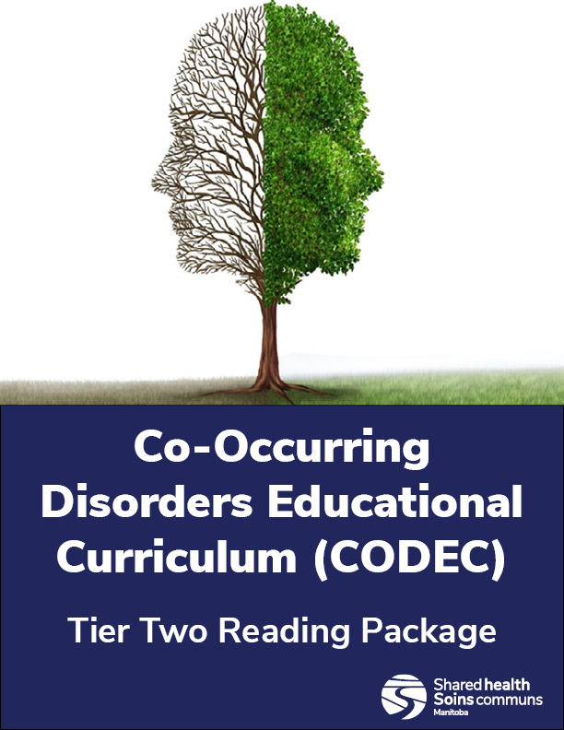

Clinical Explorations Course

Preparatory Package

**Preparatory Reading Supplement for the CODEC Clinical Explorations Course**

Before taking the CODEC Clinical Explorations sessions, ensure you take some time to read through the material assembled below. This pre-read material will provide an orientation to co-occurring principles of practice and foundational knowledge. It also reviews key concepts that you will need to be familiar with during the course.

**Terminology**

To begin, we would like to share with you some common terms that we will use during this course and how we conceptualize them.

One word you will hear us use often is **Individual.** When we say this, we are talking about the person or people accessing our services – those with co-occurring needs. In other settings you might still hear the word client, patient, or participant. We feel it is important to put the person before their relationship with us – they are unique individuals whose lives are more than just their time with us as a “client”. In practice you can also use a person’s name.

**Co-occurring Disorder** – this term is used to describe someone who is currently experiencing both a substance-use or addiction disorder and at least one other mental illness. For example, a person who has both an alcohol use disorder and an anxiety disorder. Co-occurring disorders can also be referred to as concurrent disorders, comorbid disorders, and dual disorders in the literature.

At times we also use the term “**Mental Health Spectrum**” which is meant to break down the traditional divide in our language of “mental illnesses” vs. “substance use disorders” as separate categories. When we speak of the Mental Health Spectrum, we are using language to indicate that substance use disorders are a type of mental illness, just like any other.

**Family/Natural Supports** – Due to the important roles they play in a person’s life and recovery, we often speak about their family and natural supports. Our definition of family is very broad; at its core “family is defined as a group of people who care about each other and call themselves a family” (CAMH, 2021e). It is everyone the individual has or chooses as their family. This can be anyone including biological relatives, chosen relatives, friends, caregivers, neighbours, or other people important to the individual. Natural Supports are those in the person’s self-defined family but also can include a broader network of social supports such as peer-supports, sponsors, community, or religious groups etc.

While the term is in more regular use, **Recovery,** can have different meanings and we want to clarify its use in relation to other terms such as treatment and intervention. Recovery is used as the broad term that can encompass the different types of activities and steps a person is taking along their journey to greater mental health. According to SAMHSA (2012) recovery is “A process of change through which individuals improve their health and wellness, live a self-directed life, and strive to reach their full potential.” When we speak of treatment and interventions, we are discussing specific types of medical care that the person is receiving.

**Introductory Principles**

**No Wrong Door Approach**

A No Wrong Door Approach means that every organization within the public support service system should be the ‘right door’ and offer a range of services accessible to everyone from multiple points of entry. This commits all services to respond to all the individual’s needs (mental health, substance use, or any other health care need) through either providing direct services or linkage and case co-ordination. (Mental Health Commission, 2013)

Wherever a person with co-occurring mental health and substance use problems appears in the system of care, the no wrong door approach always offers the right starting place for them to access or be connected to the services of the system. “Within an integrated system of care, there is NO Wrong Door” (Ken Minkoff, 2001).

**Trauma Informed Care** (Adapted from: Institute on Trauma and Trauma-Informed Care, 2015 and Manitoba Health- CODI, 2005)

We want to remind readers of the importance of Trauma Informed Care when working with individuals that have co-occurring disorders. Given that co-occurring disorders are so common in people affected by trauma, they should be considered expected rather than an exception. Having a co-occurring disorder and a history of trauma is associated with a variety of negative outcomes including high relapse rates, hospitalization, violence, incarceration, homelessness and serious infectious diseases (Manitoba Health-CODI, 2005).

Trauma Informed Care provides services in a manner that is welcoming and appropriate to the unique needs of those affected by trauma and related experiences. It involves integrating an understanding of past and current experiences of violence and trauma with how people cope into all aspects of service delivery. The goal of trauma informed services and systems is to avoid re-traumatizing individuals by supporting safety, choice and control which promotes health and healing. Trauma informed care should be incorporated in all stages of working with an individual.

There are different principles that guide Trauma Informed Care including:

1. **Safety:** Ensuring physical and emotional safety – creating a welcome environment and ensuring privacy.
2. **Choice:** An individual has choice and control – individuals are provided a clear and appropriate message about their rights and responsibilities.
3. **Collaboration:** Individual led decision making, goal planning, and evaluating services.
4. **Trustworthiness:** Clear and consistent goals and interpersonal boundaries are established and maintained.
5. **Empowerment:** Providing tools that prioritize empowerment and skill building.

**Comprehensive Continuous Integrated System of Care or CCISC**

**Co-occurring Standards of Best Practice** (Minkoff, 2001 & Zia Partners Inc., 2022)

The CCISC is an evidence-based model pioneered by Ken Minkoff, an originating pioneer in co-occurring care. These principles have been recognized as best-practice expectations. The model centres on eight core principles which set the picture for creating an integrated recovery-focused system of care.

**Principle 1.** “Co-occurring issues and conditions are an expectation, not an exception.”

**Principle 2**. “The foundation of a recovery partnership is an empathic, hopeful, integrated, strength-based relationship.”

**Principle 3**. “All people with co-occurring conditions are not the same, so different parts of the system have responsibility to provide co-occurring-capable services for different populations.”

**Principle 4.** “When co-occurring issues and conditions are present, each issue or condition is considered to be primary.”

**Principle 5.** “Recovery involves moving through stages of change and phases of recovery for each co-occurring condition or issue.”

**Principle 6**. “Progress occurs through adequately supported, adequately rewarded skill-based learning for each co-occurring condition or issue.”

**Principle 7**. “Recovery plans, interventions, and outcomes must be individualized. Consequently, there is no one correct dual-diagnosis program or intervention for everyone.”

**Principle 8.** “CCISC is designed so that all policies, procedures, practices, programs, and clinicians become welcoming, recovery- or resiliency-oriented, and co-occurring-capable.”

**Models of Substance Use Disorder Etiology in Western Societies** (Rose, 2023

In this section we will review some of the historic models of substance use disorders in Western societies and then we’ll also examine some of the history of mental illness models. Looking at substance use in particular, some of the false beliefs that underpin stigma associated with substance use disorders comes from the history of our models of addictions. Some of these causation theories of substance use disorders are over 200 years old and still shape our current beliefs.

Moral Model: One of the oldest perspectives on substance use, the Moral Model centered on the idea that a person’s difficulty with alcohol was due to their moral failing or weak character. Prior to the 1800’s use of alcohol was normal and essential; poor water quality made alcohol often a first choice, it was also one of only a few sources of “medicine”. Heavy drinking was often the norm, but public drunkenness was not. Public intoxication was unacceptable and could be punished. In some European countries, someone found guilty of public drunkenness could be placed in the “Stockades in the Town Square”, where they were judged, ridiculed, and even had rotten fruit thrown at them all in an attempt to shame a person into change.

The Moral Model of addiction saw the cause of the related problems as a problem within the person, they were morally weak; alcohol “abuse” was a sin and a crime therefore they needed to be punished. The Moral model is also connected to the Temperance Model which came about in the late 1800’s and viewed abstinence as the only solution.

Spiritual Model: This model gained prominence in the years post-prohibition in the 1900’s. This model views difficulties with substances as a spiritual issue stemming from a person’s lack of meaning in their life, poor sense of self, or separation from a higher power. It was felt that a person’s reason for substance use was to “fill an inner void”.

The Spiritual Model is the basis for 12-step programs such as Alcoholics Anonymous and focuses on the need to build connection, spiritual growth, and find inner peace. Spiritual connection and wellbeing can be an important part of a person’s recovery, but the model doesn’t take into account additional factors that can drive substance use difficulties.

Disease and Biological Model: Later in into the 20th century perspectives on substance use disorders began to shift away from those that were strictly related to the person’s will-power or life situations and came to include models that understood the role of the brain and genetics in the formation of substance use difficulties.

Photo from Vecteezy.com

These models recognized that substance use difficulties were progressive and relapsing illnesses that centred in the brain. However, earlier models did not balance the biological perspectives with the influence of other psychosocial and spiritual factors. We now understand that the drives of substance use and addiction difficulties often include multiple causes, as we’ll see below in the Biopsychosocialspiritual section.

**Models of Mental Illness Etiology** (Farreras, 2024)

Mental Illness and distress have existed throughout history and there have been countless theories developed to explain their origins. These theories are varied and are influenced by culture, time period, and changing morality, but generally fall into three categories:

Spiritual or Supernatural theories – these types of theories attribute mental health issues to supernatural causes such as demon possession, curses, solar eclipses, and sin or otherwise displeasing one’s deities. With these theories, treatment is generally aimed at resolving the spiritual conflict by atoning for sin or attempting to gain favour with a spiritual entity or by combating the malevolent spiritual entity at the root of the mental illness. Examples of this include healing incantations/ceremonies, exorcisms, and rebalancing “bodily forces”. There was even the prehistoric practice of “trephination” which occurred as early as 6500 BCE. This involved drilling holes in the skull to allow the evil spirits trapped within to be released.

While fewer people attribute mental illnesses to strictly spiritual causes, this is a belief that still maintains prevalence in some groups and cultures. Stigma can stem from strongly held spiritual theories that centre the cause on the individual’s sin or lack of faith.

Somatogenic theories – this category of theories attributes mental health issues to physical causes within the body. Early historic models, such as those of the Greeks in about, in 400BCE believed that illness, including mental distress, was caused by a deficiency or excess of essential bodily fluids or “humors” and that health could be regained by balancing these through activities like blood letting.

Since then our understanding of the human body has continued to develop and we now recognize that there are many complicated relationships between our physical selves and our mental health. Multiple theories focus on the role of genetics/epigenetics, neurotransmitter functioning, brain injury and even physical health – such as gut biome. Treatments are often aimed at dealing with the underlying physical causes, for example by the use of medications. While somatogenic theories move away from judgement for mental health issues, there can still be stigma attached as individuals may be regarded as “broken” or as needing to have their personal rights infringed upon ‘for their own good’.

Psychogenic theories – theories within this category attribute mental illness to mental or psychological causes, such as maladaptive learned behavior, trauma and stressful experiences, and problems with cognition or perception. These theories led to the development of psychotherapy – most famously Freud’s psychoanalysis in the early 20th century, as a means to address maladaptive thinking patterns, disordered perceptions or relieve stress. Psychogenic theories leave room for personal responsibility in seeking assistance for mental health issues, but this can create stigma in the form of blaming individuals for “not trying hard enough to get well.”

As we continue to study the etiology of mental health spectrum illnesses, we grow our understanding of how elements of all these models can play a role in the development and sustainment of illness. We now recognize multiple causes that often interplay with each other and this has led to the development of the biopsychosocialspiritual (BPSS) model as a way to incorporate our current understanding.

**Bio-psycho-social-spiritual (BPSS) model** (Borrell-Carrió, Suchman, Epstein, 2004)

The biopsychosocialspiritual model is currently the most widely accepted causation theory of mental health spectrum difficulties. This model suggests there is no one factor that causes these illnesses but that they are the result of a complex interaction between a number of factors including biological, psychological, sociological and spiritual elements. It encourages a broader treatment and recovery perspective. This is an etiological model but also an intervention and prevention model. The BPSS encourages us to look at all these factors when working to understand a person’s experience and illness. For example, a person can have genetic risks, but these can be impacted by other psychological, social and spiritual underpinnings as well as public health principles that contribute to mental health needs e.g., the more available/low cost a drug the more widespread are the health and social costs of addiction to those drugs.

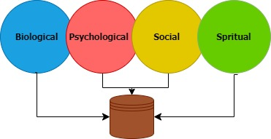

Biological: these factors have the emphasis elements such as genetics, neurobiology and pharmacology. Looking at genetics – there are hereditary risk factors and brain chemistry factors that increase the risk for difficulties. The roles of neurotransmitters and other brain structures that impact functioning is only really beginning to be understood as we gain new technology to explore the brain. There are even pharmacological effects that fall into this category which include the action of substances and medications on the brain and body.

Psychological: these factors look at the human mind, emotions, self awareness and how our surroundings affect our behaviors and cognitions. This can include elements such as our temperament and thinking styles – that is how to we interpret reality and our place in the world. Are we by nature excitable, lots of energy, always needing to be on the go, are we risk takers therefore more likely to engage in risky behaviors? It also includes our emotional processing, behaviours and coping styles, and our knowledge and comprehension.

Sociological: these factors are based on how humans relate to one another within society. These focus on interactions between people and their environments – family, peer group, cultural group as well as the social conditions individuals live within such as poverty, legal system and the other social determinants of health. This also can include observed learning – what did we witness as we grew and developed; how did our caregivers and others manage difficult situations or cope with stressors?

Spiritual: lastly are spiritual factors which encompass a broad understanding of an individual's or a group's relationship with the transcendent, however that may be construed. Spirituality is about the search for meaning. Many people express their spirituality in religious practice. While others find their spirituality through their relationships with other factors such as the natural environment, art and music, relationships with others, or through a set of personal philosophical beliefs (Sulmasy, 2002). “It can refer to many different aspects, from non-religious and non-theistic levels (such as the power of positive thinking) to deeply religious experiences” (Saad et al., 2017).

**Social Determinants of Health**

Many of the BPSS factors that impact on mental health spectrum illnesses are also influenced by the “**Social Determinants of Health**”. According to the World Health Organization “the social determinants of health (SDH) are the non-medical factors that influence health outcomes. They are the conditions in which people are born, grow, work, live, and age, and the wider set of forces and systems shaping the conditions of daily life. These forces and systems include economic policies and systems, development agendas, social norms, social policies and political systems” (WHO 2024).

The social determinants of health have an important influence on health inequities - the unfair and avoidable differences in health status seen within and between communities. Often in cities where there are all levels of income, health and illness: the lower the socioeconomic position, the worse the health outcomes for those in that group. Research shows that the social determinants can have a significant influence on health. For example, numerous studies suggest that social determinants of health account for between 30-55% of health outcomes. Addressing social determinants of health appropriately is fundamental for improving health and reducing longstanding inequities in health across all populations.

**Service Coordination: 4 Quadrant Matrix** (Adapted from Manitoba Health-CODI Training, 2005, and SAMHSA TIP 42, 2020)

(Table from: Manitoba Health-CODI Training, 2005)

This model can assist clinicians and service providers to make more informed intervention and referral decisions based on the severity and impact of each disorder. The quadrants of care model or the **“Four Quadrants Matrix”** is a conceptual framework that classifies individuals into four basic groups based on relative symptom severity of their substance use and mental health distress.

The four-quadrant model helps to categorize an individual’s areas of need for the purpose of service planning while providing the most appropriate and effective recovery options possible. As the level of need goes up, so does the requirement for more intense and integrated services. By determining which services an individual might be eligible for based on their level of need, the service provider can assist the individual in exploring various services and benefits they may not know are open to them.

**The quadrants are summarized as follows:**

**Quadrant I -** includes low severity of both substance use and other mental health concerns. These individuals can often be accommodated in primary care settings and through self-help activities. Consultation and referral to more specialized mental health supports, such as short-term counselling, can be made.

**Quadrant II-** includes individuals with higher-severity mental health concerns, but who have a low (or no) severity substance use presentation. These individuals ordinarily receive care in the mental health systems and services, which can often include therapy and case management supports.

**Quadrant III-** includes individuals who have a more severe substance use presentation or diagnosed substance use disorder or process addiction, but who have low or moderate severity for their other mental health concerns. These individuals generally are best accommodated in substance use services, with coordination and collaboration to other mental health and social services.

**Quadrant IV**-includes people whose mental health concerns are severe, complex or enduring and who also have severe substance use disorders. These individuals require more intensive, comprehensive, and integrated services for both their substance use and mental illness concurrently. They are often best supported through highly specialized services that provide more integrated and wrap around interventions. Examples include residential treatment programs, Assertive Community Treatment (ACT) teams, or in settings that provide live-in care such mental health facilities.

The purpose of organizing services into four sub-groups is to facilitate coordination of services system-wide and to achieve system level integration.  By understanding which sub-group of services would best serve a particular individual, we can identify which agency/program is best suited to address both disorders.

**Legal Information and Ethical Practice**

**Overview of Legislation Related to Personal Health Information**

There are three (3) main provincial acts that those working in Mental Health and Addictions need to be familiar with. These acts deal with the use, storage and disclosure of personal health information (FIPPA and PHIA) as well as provides a legal framework to balance an individual’s need and right to treatment, the individual’s civil rights not to be arbitrarily detained, and the need of society to prevent people from harming themselves or others when they are in a mental health crisis (Mental Health Act)

**Freedom of Information and Protection of Privacy Act (FIPPA)**

FIPPA (1997) provides Manitobans with the right of access to records of public bodies, subject to certain specified exceptions, and with protection for personal information held by public bodies. The Act also sets up the ability of the Manitoba Ombudsman to perform for independent reviews of the decisions and actions of public bodies relating to access to records and personal information protection. Those making final appeals in relation to denial of access to information can do so to Court of the King’s Bench under FIPPA.

FIPPA applies to the following:

* + Health Service Delivery Organizations (previously regional health authorities)
  + Hospitals designated under The Health Services Insurance Act (ex. Federally funded hospitals within the province)
  + Health and social services districts under The District Health and Social Services Act

**The Personal Health Information Act (PHIA)**

PHIA (1997) provides Manitobans with the right to access their personal health information, and have their personal health information kept private

* The right of access means that individuals can ask to see, or get a copy of, personal health information about him or herself. They also have the right to request a correction to this information if they feel it is inaccurate or incomplete. Access to personal health records allows people to make informed decisions, based on complete information, about their health and health care
* Health professionals and the service delivery organizations (SDO) for which they work are “trustees” of the personal health information of individuals (i.e. patients, clients) accessing health services. Personal Health Information includes:
* An individuals’ health or health care history, including genetic information;
* the provision of health care to that individual; and,
* payment for health care provided to that individual.
* It is important to understand how PHIA is collected, used and disclosed. Please see your SDO for your respective policies. For additional training visit <https://www.gov.mb.ca/health/phia/training.html>

**The Mental Health Act**

The Mental Health Act (1998) provides a legal framework which aims to provide a balance an individual’s need and right to treatment, the individual’s civil rights not to be arbitrarily detained, and the need of society to prevent people from harming themselves or others when they are in a mental health crisis.

According to the Government of Manitoba website (n.d):

* “[The Mental Health Act](https://web2.gov.mb.ca/laws/statutes/ccsm/m110.php?lang=en) of Manitoba sets out in law requirements for patients in psychiatric facilities. the Act “describes how people can be admitted to a psychiatric facility and treated for a mental disorder. The Act also applies to people on leave from a facility, and those who live in the community and are under **Orders of Committeeship”.** The Act considers two main aspects:
  + The rights of citizens under The Canadian Charter of Rights and Freedoms.
  + Society's obligation to care for people who, due to their mental illness, may not appreciate the need for treatment.”
* According to the Mental Health Act and for the purposes of that act a mental disorder “means a substantial disorder of thinking, mood, perception, orientation or memory that grossly impairs judgment, behaviour, capacity to recognize reality or ability to meet the ordinary demands of life, but does not include a disorder due exclusively to an intellectual disability as defined in The Adults Living with an Intellectual Disability Act” (Mental Health Act, 1998)

**Disclosure of Personal Health Information**

In 2019 Bill 5 was passed in the Manitoba Legislature that included amendments to both The Mental Health Act and The Personal Health Information Act to allow for trustees under PHIA to disclose confidential information without the individual's consent in some situations.

* Previously under those Acts, confidential information could only be disclosed without a person's consent to protect their health or safety, or that of others, but only if there is a serious and immediate threat to health or safety. The Bill changed that threshold:
  + Under *The Mental Health Act*, “the medical director of a psychiatric facility may disclose information in a clinical record to any person to prevent or lessen a risk of serious harm to the patient's health or safety or that of another person.”(1998)
  + Under *The Personal Health Information Act*, “a trustee may disclose personal health information to any person to prevent or lessen a risk of serious harm to a person or the public. Or to prevent or lessen a risk of harm to the health and safety of a minor.” (1997)
* For help in making these decisions please see the Personal Health Information (PHI) Disclosure Due to Risk of Serious Harm Algorithm <https://home.wrha.mb.ca/old/privacy/files/10.40.150Algorithm.pdf>

**Guiding Principles of Disclosure (Bill 5 PHIA and MH Act)**

*The following information was adapted from Shared Health Policies including “Consent to Use or Disclose Personal Health Information”, “Disclosure of PHI without Consent” and “Personal Health Information Disclosure Due to Risk of Serious Harm”.*

* Consent to disclose PHI remains best practice. Health professionals should not disclose PHI without consent where consent could reasonably have been obtained. Unless there is specific care or safety related reasons not to do so.
* In crisis situations, PHIA requires disclosure to be limited to the minimum amount of information necessary to accomplish the purpose for which it is used or disclosed. This includes information shared with family, healthcare service providers, or additional services such as police. Trustees must balance this with the fairness of engaging loved ones and their desire to have information.
* It is generally felt that Risk of serious harm means a risk to life. That risk must be imminent and probable and not just possible. Once the risk has passed, the disclosure of further PHI without consent is no longer authorized.
* When risk is not immediate, the determination to disclose PHI without consent in order to lessen risk of serious harm should be reviewed by at least two health professionals within the interdisciplinary health care team.
* The decision to disclose PHI must clearly be determined based on the individual’s needs and best interests and never considered solely or principally from the perspective of risk mitigation to the health provider.
* The individual has a right to know if a disclosure of PHI has been made without their consent and should be informed what was disclosed to whom and why at the earliest opportunity.
* Health professionals must consider accountability to the person to whom the PHI was disclosed. The person disclosed to may reasonably experience impacts of their own based on the information of risk to their loved one. Health professionals must carefully balance their authority to disclose PHI with their ethical duty to also factor potential risk to the person receiving the information. If disclosing PHI, the health professional must ensure it is meaningful information to the person receiving it. They should use plain language, not use jargon or acronyms, and make sure that the recipient has (and understands) the information needed to mitigate risk of harm, as well as the capacity to do so.
* Determination of risk must not remove an individual’s basic rights and dignity to determine their own lifestyle choices and acceptable personal risks. Self-determination and personal autonomy are integral principles of personal recovery.
* The changes to legislation have increased the importance of regular check ins to ensure that the contact list is accurate and up to date. It is recommended that providers regularly discuss and build contacts/natural supports. Individuals should be aware that they can have more than one contact person on their chart and that they may specify under which circumstances they are to be contacted. E.g. Generally a parent but if a mental health crisis then possibly a best friend.
* Document the disclosure and consultation as per the policy.
* Working with children and youth brings different challenges regarding consent and disclosure.  There are different expectations with minors under 18. Most SDO’s will have specific guidelines or processes for your role with minors, so we recommend seeking those resources out from your manager or supervisor.

**Public Guardian and Trustee of Manitoba**

Severe impairment stemming from physical, cognitive, and mental health conditions can lead to a level of mental decompensation where individuals may lose the legal capacity to manage their personal and financial matters. While it can be helpful and necessary for a small number of individuals, it is important to keep in mind this process is taking away a person’s full autonomy and so it is imperative that we consider all other options before going this route. In cases when it is necessary, a "committee", acting as a substitute decision-maker, may be appointed either by the court or by the Chief Provincial Psychiatrist to provide assistance in handling the individual's affairs. This can be a temporary or more enduring order and revaluation is part of this process.

* In Manitoba, The Public Guardian & Trustee (PGT) is appointed as committee by the Chief Provincial Psychiatrist, if no other suitable individual is available or able to fill that role. (e.g. family, friend, trust company)
* According to the website (2021a), when The Public Guardian and Trustee is Committee decisions may be made on behalf of an individual including:
  + administering personal finances
  + giving consent to medical or psychiatric treatment
  + providing legal representation
  + making decisions about daily living on the person's behalf
  + deciding where, and with whom, a person will live, either temporarily or permanently
* At times the PGT will delegate some of its authority to other health or social systems (e.g. mental health case managers, home care case managers; LTC social workers). These delegated providers may be responsible for some of the decisions in support of the individual.  The PGT does maintain responsibility for many decisions and is the final authority, so as providers we need to work closely with the Adult Service Administrator to best support Individuals we are working with.
* Please see your SDO’s policies regarding Order of Committee for more information about the process of obtaining an order and the delegate responsibilities.
* Visit the PGT Website <https://www.gov.mb.ca/publictrustee/index.html>

**Adults Living with an Intellectual Disability Act (previously the Vulnerable Persons Act)**

Some Individuals we support may be living with a diagnosed Intellectual Disability and therefor have additional types of support in decision making. Typically, these are placed into two categories *Supported Decision Making and Substitute Decision Making*. Both processes can help the individual in making decisions about their personal care, such as health care decisions, and issues of “property”, which can include financial decisions. The preferred option is for the person to utilize supported decision makers and a substitute decision maker would only be put in place if this is not working.

**Supported decision making**: this is a more collaborative process where an adult with an intellectual disability seeks assistance and guidance from their circle of friends, family, or other trusted natural support to facilitate communication and decision-making. This approach allows the person to consult with their support network for advice and assistance in making choices that affect their lives. This process is more informal in nature and keeps a higher level of autonomy with the individual.

**Substitute decision making:** this is when another individual is formally appointed to act as the person’s substitute decision maker (SDM) and assumes the legal responsibility to make certain type of decisions on their behalf. For example, they may be delegated specifically only financial decision. As well, the person acting in this capacity must still work to actively involve the individual in their own decision-making to the greatest extent possible.

The PGT is also involved as legal SDMs and may carry this role for individuals with intellectual disabilities under the Act. For more information see: <https://www.gov.mb.ca/fs/calido/substitute-decision-maker-info.html>

**Professional Boundaries**

Maintaining professional boundaries is an ongoing action that all health care providers must engage in for the safety and wellbeing of those they serve. Boundaries are clinical, legal, ethical and organisational frameworks that are in place to protect against physical, emotional and psychological harm. This includes the safety of individual’s and their families, as well as staff and the broader community. Some boundaries are firm and it’s clear when a violation has occurred, for example engaging in a sexual relationship with an Individual you are providing care to. However, many boundaries are smaller, more subtle and have some flexibility in their application, which can make them all the harder to manage effectively. For example, making personal disclosures in therapy, handling receiving a holiday gift, or responding to a Facebook friend invite. ​

There are work-place specific policies and codes of ethics that apply to all staff, as well, regulated health professionals have Standards of Practice specific to their designation (Doctors, Nurses, Social Workers etc.). It is important to know and regularly review these documents. Even if you don’t belong to a professional college good guidance can come from looking at different standards of practice and ethics models, which are available on the respective organization’s website.

**Multiple or Dual Relationships:** Multiple (dual) relationships are a particular area of concern for boundaries. They can include possible social relationships, community-based relationships such as belonging to the same organization, and digital relationships. However, it’s important to remember multiple relationships can also occur more situationally for example when the same provider is working in two settings or capacities or between past and present jobs. An example of this could working as a clinician and as a peer-worker or being a past participant who is now in a supportive/service provider role. Multiple relationships are not always a violation of boundaries but need to be monitored so they don’t become so; this is especially true in smaller communities and rural locations. As multiple relationships can occur in many ways and can change over time/circumstance, it’s important to re-evaluate them regularly, seek support or supervision when they arise and have plans for communicating concerns with the individual.

**Professional Boundaries**: also include situations and functions within the service activities of providing care – sometimes referred to as “therapeutic boundaries” this can include concerns around time and place of sessions, privacy, self-disclosure, physical contact such as touch and even boundaries related to language and clothing decisions, all of which can impact trust, safety and therapeutic outcomes.

**Keys to managing professional boundaries:**

Boundaries and ethical practices requires you to *always* put the welfare and recovery of the individual first and differentiate these things from your own needs.

* Set and adhere to clear expectations/roles, limits of confidentiality and recovery plans/actions.
* Establish ongoing communication related to boundaries with the individual.
* Maintain the individual’s privacy, including being aware of setting and sound.
* Plan ahead for the management of boundary crossings and multiple relationships.
* Be aware of the possibility of extended boundaries such as with the person’s family or community.
* Actively limit the number and types of relationships you have with an individual (ideally just one role).
* Ask yourself reflective questions and consult with colleagues, leadership and ethics.
* Access regular clinical supervision to explore boundaries.
* Document your thinking process, consultations and plans of action.

**Boundaries and Social Media:** Social media has become a pervasive method of sharing any and all kinds of personal and sometimes professional information. It is a fast-changing landscape, rife with pit-falls for those in professional and care-providing roles. First and foremost, you have a responsibility to protect confidential and personal health information of those you serve. Breaching this can be as simple as identifying someone online as a participant in your program. ​

Interacting with others through social media comes with unique risks. Social media “blurs the lines between one’s personal and professional lives” while offering “instantaneous posting opportunities that allow little time for reflective thought”. Social media provides easy means to share more information, with more people, than would be ever possible through in-person conversations. It also means that images or comments posted in haste, and later regretted, can be difficult if not impossible to remove from the public domain.

Photo from Vecteezy.com

Privacy settings can mitigate the risk of information being spread more broadly than intended, but even with these settings enabled, posts can be screen captured, saved and disseminated by others. Any information posted online, even if quickly deleted, may remain accessible to unknown sources. (Zur, n.d.; APA ,2017; Relationships Australia Victoria, n.d. and CRNM , 2019)

**Some Tips to maintain appropriate professional boundaries when using social media platforms:**

* *Turn on privacy settings*. While not an entirely effective means of keeping information out of the public domain, secure social media accounts can help you maintain appropriate boundaries with individuals you are supporting.
* *Do not accept requests* from people you serve, or send requests to them, to engage through personal social media accounts.
* *Do not seek out information on individuals from their social media accounts*. This is a boundary violation and if the information were used to inform their health care and collected without their knowledge, might be a violation of The Personal Health Information Act (PHIA).
* *Be responsible* for ensuring that your online conduct meets the standards of your profession, as well as applicable legislation (such as PHIA) and your employer’s policies.

**Recovery, Intervention and Treatment Principles**

**Motivation to Change/ Stages of Change**

(DiClemente 2018; Flannery, 2017; Manitoba Health-CODI, 2005; Prochaska and DiClemente, 1984 & SAMHSA TIP 35, 2019)

(Adapted from Prochaska and DiClemente, 1984 and DiClemente 2018)

As clinicians it is helpful to understand the phases of change when working with individuals in recovery. The most well-known concept is the *“Stages of Change”* theory from Prochaska and DiClemente, which is part of their larger Transtheoretical Model of Change framework. This model breaks motivation for change down into several parts, with different sets of thoughts, feeling and experiences. It is important to keep in mind that, while often presented sequentially, individuals often flow back and forth between these stages. We call this effect “recycling” and it is a normal part of the process. As well, a person can be at a different level of change for different elements of their co-occurring difficulties. That is a person may be in an action stage of change for addressing anxiety but in a precontemplative stages for their alcohol use.

Precontemplation Stage of Change: the individual is not thinking about making a change in their behaviour as they are not aware of the need for change. At first this may appear to be from a lack of motivation, but it’s actually a need for self-discovery. People in the stage of change need to be reassured that they will not be pressured into changing. At this stage it is helpful to engage them to identify the negative consequences associated with their behaviour.

Contemplation Stage of Change: the person has started to think about making some changes but are still undecided. The person needs to have both their desire to quit the behaviour and their desire to continue the behaviour acknowledged in order to help them to realistically assess the risks associated with continuing the behaviour. At this stage of change people have acknowledged information about their behaviour and are stating to make personal connections.

Preparation Stage of Change: this stage involves individuals actively contemplating and planning for specific actions to modify their behavior or situation. However, people in this stage can sometimes get stuck on information and believe that thinking is action. Even though the person has committed to making a change, they need to begin to plan how they will do it. Three of the major tasks of this stage of change include: identifying why they are making the change, developing a plan for how to make the change and identifying supports and other preparation for the change.

Action Stage of Change. In this stage, the person is actively making changes through modifying behaviours. In this stage a lot of support and reassurance is needed as the person faces unknown situations with new, untried skills. When people are in this stage you can easily identify them as they are making observable, obvious changes in behaviour. This stage requires the greatest commitment of time and energy. It’s important to be aware that in the first month or two, there can be a greater risk for resumption of old behaviours due to feelings of being overwhelmed by the amount of effort involved. As time passes, people can start to increase their sense of self-esteem as they realize they are successfully achieving changes.

Maintenance Stage of Change. During this stage, the person is consistently maintaining changes that they have made over a prolonged period. In the maintenance stage of change, people are still vulnerable to situations that can trigger the old behaviour. Self-efficacy continues to build by assisting the individual to use the new skills they are learning to handle on-going situations and risks. Some people may remain in the maintenance stage of change for a prolonged time, which is still considered a success.

Termination Stage of Change. Here the person no longer needs to attend to the task of maintaining the change. The person can now shift efforts away from maintaining the behaviour change and focus on other goals or changes, building on the skills they’ve developed.

**Recovery & Change** (SAMHSA Tip 35, 2019).

The Transtheoretical Model of Change also identifies different processes that individuals use to implement change. The theory suggests that some strategies/processes are more beneficial when used at certain stages of change as opposed to others. The most common 10 processes are divided into 2 categories: Experiential and Behavioural as described below:

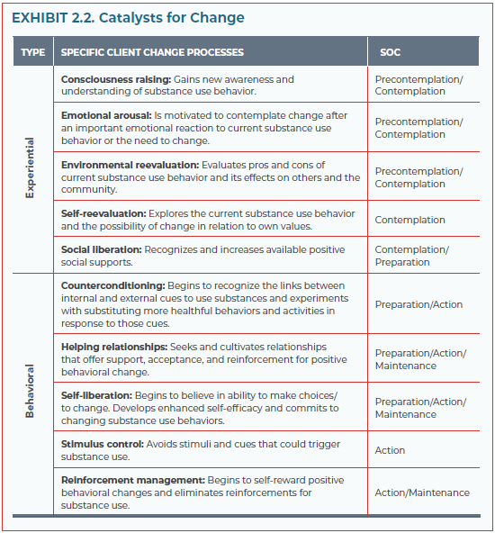

(Table taken from: SAMHSA Tip 35, 2019).

As indicated above, the Experiential Processes of Change move from consciousness raising, emotional arousing and environmental re-evaluation (where individuals may be in precontemplation and contemplation) to self re-evaluation and social liberation (where individuals may be in contemplation and preparation). The Behavioral Processes of Change moves from counterconditioning, utilizing helping relationships, and self-liberation (where individuals may be in preparation, action, or maintenance) to stimulus control and reinforcement management also known as rewards in the action and maintenance stage of change.

Individuals shift back and forth between stages of change depending on life situations, stressors/problems, beliefs and attitudes, interpersonal relationships, social systems, and enduring personal characteristics.

**Motivating Interviewing: A Brief Overview** (MINT 2021, SAMHSA Tip 35/42, Miller and Rollnick, 2013).

Motivation is the key to substance use behavior change. Motivational Interviewing is a strategy for having conversations that help and empower people to discover and act on their own motivation to change. It gives us a set of tools to guide a person through change even if they first present without such desire or without external motivators.

*To learn more about Motivational Interviewing please take the “Health Behaviour Change” courses available on LMS or read the Millner and Rollnick books.*

In motivational interviewing you become a helper in the change process, expressing acceptance of the individual while helping to resolve the ambivalence that prevents them from realizing personal goals. MI centers on personal ambivalence, which is presented as a normal occurrence that keeps people from reaching their goals. It can be used in combination with various types of psychotherapies, including CBT and is in line with person-centered and recovery-oriented principles.

The most current version of motivational interviewing is described in detail in Miller and Rollnick (2013) Motivational Interviewing: Helping people to change (3rd edition). Key qualities include:

It is a guiding style of communication, that sits between following (good listening) and directing (giving information and advice).

Its intention is to enable individuals to initiate change by eliciting their own significance, value, and potential for transformation.

It is based on a respectful and curious way of being with people that facilitates the natural process of change and honors client autonomy” (MINT, 2021).

**MI Elements:** MI consists of the following elements that work together.

* the principles
* the spirit
* the MI process
* the MI techniques/skills

(Diagram adapted from: Rosengren, 2018; Miller & Rollnick, 2013)

**The principles of Motivational Interviewing** can be described using the acronym RULE:

R – resist the righting reflex – the tendency of clinicians to actively attempt to fix problems in the lives of those they work with. With good intentions, we may wish for the individuals we work with to lead healthier lives without considering the possibility of ambivalence.

U – understand the person’s motivation by seeking to understand their values, needs, abilities, desires, and potential barriers to changing behaviours. Express empathy.

L – listen. This can help to develop discrepancy between their goals/values and their current behaviours.

E – empower the person you are working with to set achievable goals to overcome barriers. Support self-efficacy.

**The Motivational Interviewing Spirit** is characterized by a particular “way of being” that guides the practice of motivational interviewing. The spirit of is comprised of 4 theoretical elements which can be remembered as PACE:

Partnership - describes the nature of the relationship between the clinician and individual.

Acceptance – describes the deep appreciation of the individual and their worldview, the absolute worth of all individuals, accurate empathy, autonomy support, and affirmation.

Compassion – guides the clinician to put the needs and priorities of the individual before their own and is the foundation of a trusting relationship.

Evocation – evoking an individual’s strengths, resources, solutions, motivation for change. It is important to note that the spirit is integral to the ethical practice of MI and is the foundation of which MI is built.

**The Motivational Interviewing Process** includes four fundamental processes that describe the “flow” of the conversation although we may move back and forth among processes as needed and include:

a) Engaging: the goal is to establish a productive working relationship through careful listening to understand and accurately reflect the person’s experience and perspective while affirming strengths and supporting autonomy (Rosengren, 2018).

b) Focusing: centers on guiding the individual to a target behaviour that is important to them. The focusing process includes agenda setting, asking the person what is important to them and gathering more information. Exploring the individual's goals and values can help them to see what behaviours are inconsistent with what they say is important to them.

c) Evoking: in this process, the clinician gently explores and helps the person build their own “why” of change through eliciting the individual’s ideas and motivations. Ambivalence is normalized, explored without judgement and as a result may be resolved. This process requires the clinician to attend closely to a person’s talk about change.

d) Planning: involves delving into the practical aspects of change – or the “how” , with the clinician assisting the individual in reaffirming their dedication to change while crafting a plan rooted in the individual's own understanding and expertise.

**Motivational Interviewing Skills and Techniques**. There are multiple techniques used within the intervention and the following are a sample of some of those. Many have acronyms to help you remember them.

a) “DARN CAT” questions. This acronym helps you remember the kinds of questions to ask to get people talking about making changes. They include using questions to prepare a person by eliciting their “desire, ability, reasons and need”. This is followed by mobilizing language including questions about “commitment, activating and taking steps”.

b) Core Skills which include:

* Asking open-ended questions
* Using scaling questions
* Doing Decisional Balance Sheets
* Providing affirming statements
* Using reflective listening including repeating, rephrasing and double-sided reflections
* Summarizing statements and discussions
* Informing and Advising, with permission
* Rolling with resistance (ambivalence)

**Screening and Assessment**

**Mental Status Exam** (Crisis Response Services, 2021)

**“The** **Mental Status Exam (MSE)** is a standard tool used by clinicians to assess the basic functioning of a client. An MSE is often completed during an initial psychosocial assessment, and at regular intervals throughout treatment. The assessment categories include mood, cognition, perception, thoughts, behaviors, insight, and judgement” (Therapist Aid, 2021f).

Items assessed in the MSE:

* + **Appearance**: comment on apparent age, clothing, hygiene, facial expression, any other distinguishing features (e.g.: tattoos, scars, piercings).
  + **Engagement/behaviour**: eye contact (wandering, distractable, avoiding, constant, appropriate), attentiveness, alertness, attitude, cooperation with interview.
  + **Psychomotor Activity**: psychomotor agitation or retardation, tremors, tics, mannerisms, akathisia.
  + **Posture**: slumped, rigid, tense, fidgety, atypical, exaggerated or stilted posture, catatonia.
  + **Speech**: rate/volume/tone of speech, variation in cadence and rhythm.
  + **Mood**: individual’s description of their emotional state (e.g. angry, sad, irritable, elated, anxious).
  + **Affect:** observation of emotional state. Could comment on range (restricted, expansive, appropriate), intensity (flat, dramatic, blunted, labile.) Comment on congruence/appropriateness to mood and topics discussed. Euthymic, dysthymic.
  + **Thought Process**: description of a person’s flow of thoughts. For example; circumstantial, tangential, flight of ideas, looseness of association, organized, linear, coherent, thought blocking, fragmentation, incoherence, perseverative, fragmented thought process.
  + **Thought Content**: what topics and types of thoughts does the individual focus on. Presence of delusions (paranoid, grandiose, jealous, persecutory), overvalued ideas, obsessions, phobias/fears, preoccupations. Comment on presence/absence of suicidal/homicidal ideation.
  + **Perception**: comment on presence/absence of hallucinations, illusions, depersonalization, i.e.: describe auditory, visual, tactile, olfactory experiences. Consider whether the experience occurs when hypnagogic (only when falling asleep) or hypnopompic (only when awakening) which can be normal. Comment on presence/absence of command hallucinations, difficulty attending to conversation, rapid changes in facial expression, looking frightened, talking to themselves.
  + **Cognitive / Executive Functioning**: orientation to time, person, place. Attention and concentration capacity, notable memory difficulties, intelligence estimation (noting that not formally tested), ability to think in abstract vs. concrete terms.
  + **Insight:** level of awareness of one’s difficulties (i.e. good, sound, partial, limited, poor).
  + **Judgment:** comment on the individual’s decision-making, problem solving ability.

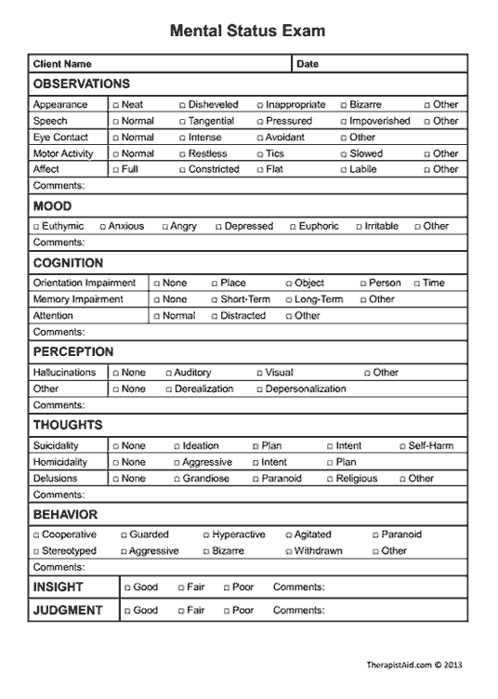

(Picture from: Therapist Aid, 2021f)

**Assessment Principles**

**Comprehensive Integrated Assessment** (SAMHSA Tip 42, 2020)

Co-occurring capable assessment should be comprehensive and present a holistic review of the individual both historically and currently. Comprehensive assessments lead to improved outcomes and higher satisfaction in the service from the individual's perspective. The assessment must also be integrated, which means mental health and substance use/addictions issues are to be assessed concurrently and within the context of each other.

Part of completing a compressive assessment is the inclusion of multiple sources of information that can be collected in different ways.  At an individual level this can mean combining information gathered from a clinical interview with standardized measures.  However, this also means including other, external, sources of information from collateral sources which supplement what has been shared by the individual.

Two main sources are: information from other service providers, such as a family doctor, and equally important is information from natural supports such as family, friends and peer support. Not only does this help in achieving a more holistic view of the individual but can be critically important in cases where the individual has internalized stigma or broken trust, is a poor historian due to cognitive or emotional deficits or has impaired insight as a result of their mental illness or substance use.  However, this process must be done carefully, respectfully, and with the consent of the individual, while keeping in mind they remain the expert on their own experiences.

Photo from Vecteezy.com

Keep in mind that when assessing, we must balance the need for information gathering with engagement. The individual is an active participant in the assessment process and their joint-ownership can facilitate more open and accurate sharing of information and lead to better outcomes.

Consideration should be paid to the individual’s level of cognitive, behavioral and social functioning when conducting assessments.  The nature of co-occurring disorders, including trauma history, can impact a person’s attention, memory, executive functioning, emotional regulation and other elements which can influence how they are able to participate in the assessment.  Depending on the individual’s abilities, as the assessor you may need to adapt the language you use and the method of delivery – for example using visual tools instead of verbal ones, changing the length of the session and involving others for support.

**Components of Comprehensive Integrated Assessments** (Alberta Health Services, 2016; Health Canada, 2002; Manitoba Health –CODI, 2005; Marel et al, 2016; SAMHSA Tip 42, 2020)

The individual’s reason for coming (presenting issues) and recovery goals

Presenting needs, what the individual perceives to be their biggest issues and the reasons why they are seeking help. Keep in mind, this is usually broader than just the mental health spectrum issues and can include other psychological, social, health, legal, housing and financial needs. This is also an opportunity to start thinking about what will be recovery goals.

Demographics

In addition to providing important information on aspects of the individual that can impact their medical health and treatment options, this is also an opportunity to begin important conversations around which social determinants of health ​may be impacting the individual.

Referral source and other health care providers

As part of continuity and collaboration of care it’s important to know and, when possible, receive consent to work with the referral source as well as other providers. ​

Individual’s strengths

Strengths are an important part of assessment and attention should be paid to exploring and understanding the individual’s abilities and skills, as well as getting to know their supports and how they utilize resources. It’s important to keep in mind some individuals may not see their own strengths and so extra work may be needed to help them discover these. This may include reframing past experiences to be affirming of their strengths instead of deficits. Strength‐based assessment should begin with identifying the individual’s most important recovery goals for a life worth living.

Current mental status

A crucial component of the assessment process is the evaluation of the individual’s mental state and presentation during the session. This is often obtained through observation and is a clinical impression. The Mental Status Exam,discussed above, is an example of a structured and broad assessment of multiple components of someone’s mental status, appearance, and behaviour.

Insight and judgement

During the assessment process clinicians are also gathering an impression of the individual's insight into their needs and their judgment. Both acutely at the time of the session and more general impressions. It should be noted that these factors may be affected by intoxication or withdrawal from substances.

Medical (physical) history

Comprehensive assessments should also incorporate information on current and past medical concerns, often collected from collateral sources including specialists. It is important to review if there are medical co-morbidities or other underlying physical health issues as these too can have an impact on the identification of, and nature, severity and course of mental health spectrum difficulties. Much like the interplay of mental illness and substance use – the impact of physical health concerns can precipitate, mimic, mask or exacerbate co-occurring disorders and vice versa. For example, in individuals with poorly managed diabetes the changes in blood sugar levels can lead to mood dysregulation or worsening symptoms of anxiety. These levels may be further impacted if there is alcohol use, which may mean different interventions are needed to address the concerns. ​

Suicide and other risk assessment

Full suicide risk assessment is part of a comprehensive assessment and goes beyond asking if the person is suicidal at the moment. It includes risk and protective factors, current and historic specific suicidal inquiry including attempts, plans and intent, collateral information and safety and risk planning. Assessing for other risk factors such as aggression and intent to harm others is also important for the safety of the individual and others. Please see your SDO policy for further information and practice expectations.

Personal and family history

This section of the assessment will cover a large range of topics including: social determinants of health, self and family history of mental health spectrum difficulties, family/relationship and social dynamics and needs, access to resources and supports, work and education history, legal history, spiritual or religious affiliation, cultural considerations, and linguistic needs

Functional assessment and functional analysis of mental health spectrum concerns

Building on the information already gathered, the functional assessment and functional analysis are often some of the most detailed sections of the assessment and pull together the history and current experiences of substance use/addictive behaviours and mental health concerns including trauma.

This can include details of symptom experiences and information on the onset, influencing factors, frequency, intensity and impact of symptoms. Also explore existing diagnoses or past diagnoses, history of system involvement including acute and community care and past recovery interventions including medications and why these were successful or unsuccessful.

It is also important to gain an understanding of the range of substances currently used, the quantity and frequency of use, duration of use, previous substance-related problems, circumstances and risk of use. Exploration of substance use should also look to understand how a person’s use developed over time, periods of abstinence, the role the substance use or addictive behaviours play in their lives, current situational and contextual factors that maintain use behaviours and how these interact in relation to other mental health difficulties.

The impact of co-occurring mental health and substance use disorders on a person’s life will also have interactive effects on each other in complex ways, which is why it is important to examine each illness not only on its own but in relation to the others. Figuring out which interaction effects are present can be the most challenging part of the assessment and is usually an ongoing process as the interactions are dynamic, fluid and change over time. Often there is at least a one-way interaction where the symptoms or behaviours of one illness plays on the other. But, over time the effects tend to feed into each other, sometimes leading to recurrent circles of interaction with no simple cause-and effect solution. ​

Functional Capability ​

Current level and impact of impairments is determined by assessing functional capabilities and can influence the types of supports needed and the recovery plan. Those with more areas of deficit will likely require higher and more intensive amounts of support. General clinicians may explore this domain within their scope of knowledge however, further specialist assessment such as Psychology or Occupational Therapy may be needed.

Areas to consider include general impressions of independent living skills including if they can engage in Instrumental Activities of Daily Living (IADL) and Activities of Daily Living (ADL). How well are they managing their living environment, finances and other activities? Further assessment by a specialist of cognitive functioning may also be needed including determining if there is a history of developmental or learning disabilities and the person’s literacy skills. ​

Integration of co-occurring disorders - Interaction effects

Interaction patterns can include symptom relief/exacerbation, triggering/eliciting effects, or mimicking/masking where one hides or worsens the other. As well the illnesses can also interact with the social determinants of health which can change the course of recovery. In addition to the information collected as part of the Functional Assessment it is important to explore the chronological history of the multiple disorders, with an eye for how they have related to each other at different time periods. Also keep in mind, as a result of interaction effects, recovery in one area can impact the other in positive or negative ways. For example, someone with trauma who stops using their substance of choice may experience an increase in panic attacks without having other coping skills. ​

Stage of readiness for change and motivation

Include an evaluation of the individual’s motivations and readiness for change (stage of change) which fluctuate over time. It’s important to assess how ready the individual is to make behaviour changes related to each element of the co-occurring concerns. A person may be at different stages of change for different elements of their co-occurring disorders. For example, being ready to abstain from alcohol but not cannabis.

**Ongoing and Focused Assessments**

It’s also important to remember that assessment with the individual is an ongoing process and as involvement and interventions occur, clinicians continue to collect and incorporate this new information. As recovery plans proceed and as other changes occur in the person’s life, we must actively seek current information rather than proceeding on assumptions that may no longer be true or accurate. ​Ongoing assessments can have a variety of purposes, which can lead to different questions being asked, methods and measured used and change the goal or expected outcomes.

Identifying and communicating the purpose of the assessment is important, particularly for additional assessment.  When as clinicians we are clear in our purpose in advance this allows for questions to be asked in a more focused and organized manner allowing maximum information to be shared with the least amount of questions asked.  As well, it’s important to share with the individual before starting, the reasons for the assessment, how it may help them reach their goals and the purpose of different measures or instruments if they are used.  This may also be a time to provide reminders about confidentiality and how the information will be used. ​

**Key considerations to support assessment**

* + Assessment should aim to be comprehensive and integrative of all the co-occurring concerns.
  + Use person-centered, welcoming, trauma-informed, culturally sensitive, recovery focused and non-judgmental approaches.
  + Identify strengths and supports.
  + Balance the need for information gathering with activities of engagement and the individual's level of comfort and functioning
  + Engage in assessment as an ongoing process.
  + Be purposeful in what information is gathered.
  + Include multiple sources of information in addition to self-report (with consent).
  + Ensure good documentation of results and interpretations of findings
  + Refer to additional specialised assessment (psychiatry, psychology, OT) as needed

**Crisis and Suicidality** (Goldner, Jenkins & Bilsker, 2011; NAMI, 2018; Regehr & Glancy, 2014)

This section is meant to provide a general overview of the concepts of crisis and suicidality. For more information on recognizing and responding to suicide risk consider taking part in **Applied Suicide Intervention Skills Training (ASIST)** training. For more information on Suicide Risk Assessment, clinical staff are encouraged to complete the **Shared Health Suicide Assessment, Intervention and Monitoring (SAIM) and Suicide Assessment and Intervention (SAI) trainings through LMS**. Please check with your manager for other SDO specific offerings.

**Crisis** in mental health is broadly defined as the subjective experience of distress and feeling overwhelmed – usually that come on suddenly and that causes the individual’s regular coping strategies to be overwhelmed and reduced in response to various stressors. According to the National Alliance on Mental Illness (NAMI) “A mental health crisis is any situation in which a person’s behavior puts them at risk of hurting themselves or others and/or prevents them from being able to care for themselves or function effectively in the community” (2018). A crisis is usually time-limited. The nature of crisis response is multifaceted and affected by various components including:

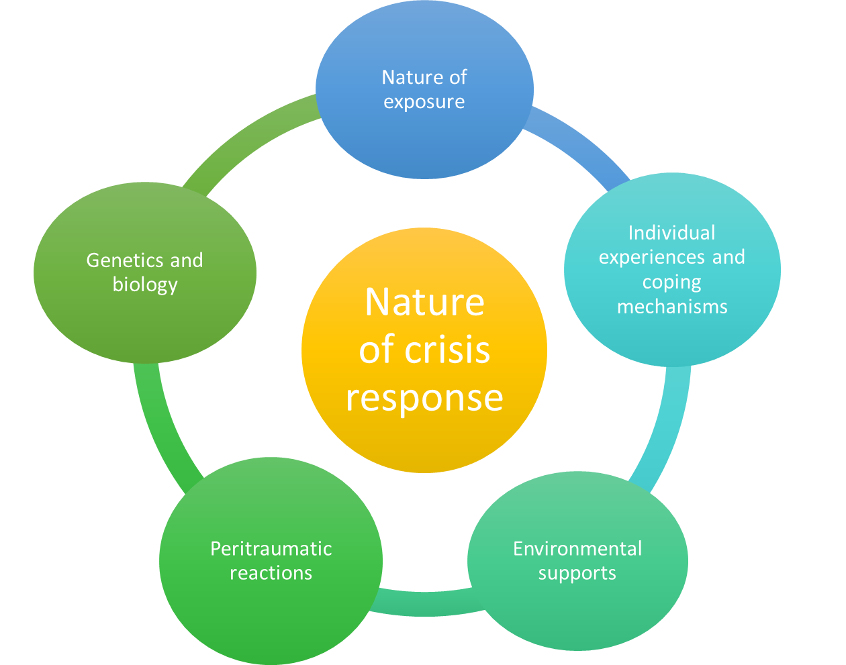

(Regehr & Glancy, 2014)

* *Nature of the exposure*: type of trauma exposure, duration, frequency
* *Individual’s experiences and coping mechanisms:* the ability to cope develops through life experiences that either promote and build resilience or weaken it. Early developmental experiences can influence one’s ability to employ coping strategies during times of increased stress and crisis
* *Environmental supports:* the degree to which individuals have access to supports both pre and post crisis. These can be familial or personal supports, as well as healthcare and professional supports. Larger societal and cultural attitudes towards stress, crises, and mental health can impact the amount of support offered/received, as well as an individual’s help-seeking behaviours. The more supports available and received, the better the outcomes
* *Peritraumatic distress reactions:* this “refers to the reactions to the appraisal of risk”. The experience of this type of distress has been linked to persistent symptoms of PTSD. Two aspects include psychological (the experience of fear, helplessness, horror) and physiological (trembling, sweating, tachycardia). Timely intervention can lead to better outcomes in those exposed to traumatic events.
* *Genetics and biology*: Genetic and biological differences play a role in individual reactions to stress/crisis responses. Factors such as temperament and physical health can impact one’s ability to cope.

**Responding to Crisis** (Roberts et al., 2005)

**Roberts’ 7 stage Crisis Intervention Model**

1. Psychosocial Assessment - this assessment should cover the individual’s environmental supports and stressors, medical needs, medications, current substance use, coping methods and resources. Should also assess risk for harm to self or others
2. Rapidly Establish Rapport – facilitated by offering genuineness, respect and acceptance of the individual.
3. Identify the Major Problems or Crisis Precipitants – focusing on the individual’s current problems, often the ones that precipitated the crisis. Looking at why someone is presenting for services now.
4. Dealing with Feelings and Emotions – Striving to allow the individual to express feelings, explain their story about the crisis. Relies on service provider engaging active listening skills. May involve service provider utilizing ‘challenging responses’ which can include reframing, interpretations, and providing information to hopefully support individuals in reframing maladaptive beliefs.
5. Generate and Explore Alternatives – Service provider and individual discussing productive options for support (safety planning, appropriate community supports, hospitalization). Often helpful to discuss what has or has not worked in previous crisis events. When possible these alternatives should be collaboratively generated and chosen by the individual.
6. Implement an action plan - Strategies become integrated into an empowering treatment plan
7. Follow up – Should plan for follow up contact with the individual to ensure that the action plan is being worked on and to evaluate the post crisis status of the individual.

**Suicidality**

The American Psychological Association defines **suicidality** as “the risk of suicide, usually indicated by suicidal ideation or intent, especially as evident in the presence of a well-elaborated suicidal plan.” (2018) The broad term of suicidality can also cover thoughts of suicide, plans, actions, or attempts. **Suicidal ideation** (SI), also known as suicidal thoughts or ideas, refers to various thoughts, desires, and concerns related to death and suicide.

**Risk and Protective Factors.** Examining the whole picture in assessing an individual’s risk for suicide includes not only identifying what crisis exists – this can be something small or something large, but also examining modifiable and non-modifiable factors that can impact a person’s coping and stress. Some risk factors may turn into triggering events in a crisis. With these we are looking to understand how the person describes their functioning and experiences prior to the event, what impact they perceive is relevant on their current coping and how that may have changed. It’s important to develop an understanding of the impact of the trigger so that it can be more readily identified in relation to safety planning. This may allow for different resources to be used in the future before an event becomes a crisis. Protective factors are those resources, supports and characteristics that can decrease vulnerability to suicidality.

**Examples of Risk Factors in Adult Populations Include:**

* Substance/alcohol use
* Living with mental illness/stigma
* Past suicidal ideation/behavior
* Serious or chronic health conditions/pain
* Stressful life events including, homelessness, death, divorce/separation or job loss
* Prolonged stress factors including harassment, bullying, relationship problems, financial problems
* Employment, or school difficulties
* Access to lethal means including firearms
* Social Isolation
* Recent hospitalization
* Community factors such as exposure to violence and suicide

**Examples of Protective Factors in Adult Populations Include:**

* Effective coping and problem-solving skills
* Having reasons for living (family, friends, pets, life goals)
* Strong cultural identify
* Supportive family and friends
* Connection to community
* Access to health care and other supports



Photo from Vecteezy.com

WAY TO GO! You made it all the way through. We look forward to seeing you at your upcoming Clinical Explorations CODEC course.

Additional Supporting Documents including a reference list, additional resources/websites and a list of recommend training can be found on the LMS listing for the CODEC training sessions.