This document has been created to guide users of the unit/area response plan templates. The templates have been designed to provide consistency in emergency management colour codes across units, areas and sites while they develop their internal response plans.

The templates were created and are maintained by Emergency and Continuity Management (ECM), Emergency Response Services, Shared Health. If you have questions or require support, please contact ECM at **ECMOperations@sharedhealthmb.ca**.

Templates can be found here: [**https://healthproviders.sharedhealthmb.ca/services/ers/ecm/**](https://healthproviders.sharedhealthmb.ca/services/ers/ecm/)

# Instructions for Use

* When downloading templates, please ensure to select **“Save”** or **“Save As”** to ensure formatting is maintained properly.
* Insert your unit/area specific information within the indicated areas.
* Font and headings should be formatted according to the below standards to remain consistent.
* In the checklist sections where job role is indicated, you are to change these to the relevant roles and departments of your unit/area. Roles could include housekeeping, security, etc. or clinical staff roles including manager of patient care, nurse educators, CRNS, RNs, IP&C, Health aid, etc.
* To add additional roles in the checklists, copy the job title and paste into the location you need it.

# Fundamentals

The fundamentals section should be used to add information relevant to the response plan but that will not be captured in a checklist within the plan. The information indicated here may be indicated in the site wide contingency plan.

Information included under fundamentals may be site wide universal actions associated with the specific code, communications/media management processes, initial escalation points to admin on call, how supplies are obtained, etc.

Additional supplementary fundamental section items can be added with new titles as are relevant to your unit, area and site response. Listed below are examples for reference, but are not inclusive as you are your unit/area/sites expert in what is needed.

*Example fundamentals using the unit/area response plan template formatting:*

**Actions all site wide staff to complete**

* Run, hide, fight

**Security Services**

* Will only restrict building access under the Director of the Coordinating Command Centre. Restrictions apply to the Emergency Parking areas, the general loop, the MS loop, D-Lot and Women’s loop.

**Support Services**

* Housekeeping, Maintenance Services or Hospital staff may be called upon to assist with door opening, traffic control or other related duties if insufficient Security staff is available. Requests for assistance may be made through the Coordinating Command Centre if situations dictate the need; this will be at the discretion of the Supervisor on shift.

**Equipment and Supplies**

* Security will use portable radios and companion phones as needed.
* Maintenance services will provide extra radios if required.
* Equipment and signage will be stored and maintained appropriately.

**Communications**

* Security and Maintenance Services will combine resources to provide additional radios should the need arise.
* Shared Health Communications will manage all media requests and will attend to site if required.
* Shared Health Communications to determine media marshalling point and communicate the location to Security Services Supervisor on-call.

# Font and Headings

Font and heading information are listed below. Text style formatting should be maintained when the document is downloaded and saved.

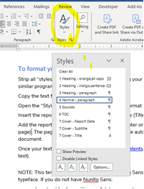

If when saving the file, the formatting was not maintained, you can format your file to align with the template using the information below. Open “Styles” and use the text style formatting listed below to format your text.

# Text Style Formatting

**1 HEADING – Black, ALL CAPS, Arial, Bold, size 18**

**2 HEADING – BLACK, ALL CAPS, Grey highlighting, Arial, Bold, size 18**(used for “phase” headings)

**3 Heading – Black, Ariel, bold, size 12, coloured underline based on code colour**

Normal – paragraph, Arial, size 12

# Checklists

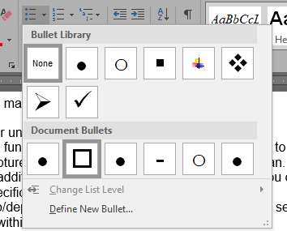To create the checklist, use bullets and select the square.