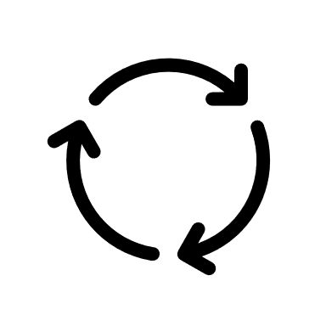
5 minute 5s Audit Template

- One person checks the area each day.
- Indicate if the area matches the perfect state photo (Everything OK) with a Y or N.
- If something is out of place it must put it back in place and indicate on the audit what it was.
- Once the team reaches 90% compliancy, auditing can be performed on a weekly basis.

Date | Name | Everything OK  (Y/N) | What Requires Adjustment

