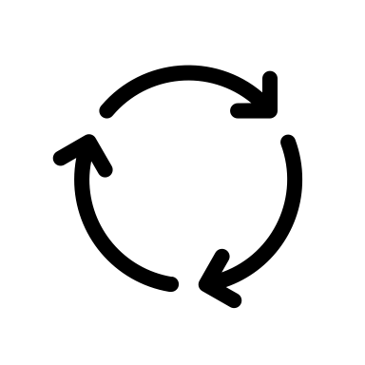
Communication Plan
Questions and Answers

Program/Department:
Project Name:
Team Facilitator:

Questions and Answers
 | Questions  What questions do you think staff are going to ask about the project? | Answers  Craft Your response to those questions
1 | Example: how long will the project take? | The project will take place over the next 3 months. There is an anticipated finish date of May 25, 2022
2
3
4
5
6

